NP

NEWS

DATES TO REMEMBER
Friday, March 16; Last day of the Marking Period
Last Friday Folder before break
Thursday, March 22; Report Cards – 3:00p Dismissal
Friday, March 23; Professional Dev. – NO SCHOOL
March 26-April 8; Spring Break – NO SCHOOL
PIZZA FRIDAY
Friday, March 16 was the last Pizza Friday.
Any money prepaid for weeks to come,
has been returned in an envelope in the
3/16 Friday Folder.
REPORT CARD NIGHT
We will NOT hold conferences with teachers on this night. There is no need to come in to the building to pick your
student up, we will bring the report to your car at dismissal. If your student walks, we will mail the report home that day.
3/22 LUNCH
Thursday, March 22 St. Mary Magdalen School is providing us lunch; Pizza & Cookies!
8TH GRADE BABY PICS
8th grade parents, it’s that time, PICS FOR GRADUATION!
If each 8th grade family can provide us with 5-10 pictures from your student’s younger days, we promise you won’t regret it.
You can email the pic to Ms. Jessica or drop them off to the school so we can scan them. Please have pics in by April 20.
SERVICE CLUB
Service Club is holding a
‘soda tab drive’ for the
Ronald McDonald House.
Save the tabs from cans of
soda or other aluminum
cans, and bring them to the
front desk of NP. Students
can earn points for their house,
the house with the most tabs is the winner!
IN THE SPOTLIGHT

NEWSPAPER
CLUB
Check out their first Newsletter in your Friday Folder!

WELCOME
Please join us in welcoming our newest member to the NP Family…
D’Brickashaw “Brick” Davis
VOLUNTEER OPPORTUNITIES
Looking ahead at some opportunities to not only get some mandatory hours, but to also give your time and talents to NP.
-Speaking on NP’s Behalf – TBD
-New Student Referral – 2hrs each accepted student
-NP Community Yard Sale – 4/28
-NP Art Show – TBD (May)
-Graduation – June 7 (limited spaces)

50/50 RAFFLE
We are selling tickets for a 50/50 raffle! The winning number will receive half of the proceeds, while the other half will go towards the school’s tuition free program.
Each ticket is $1.00 or 6 tickets for $5.00.

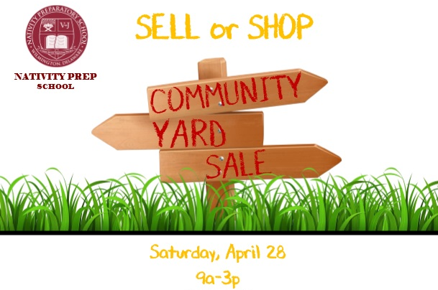
Please see Ms. Jessica for tickets.

